Univariate - Percentile¶

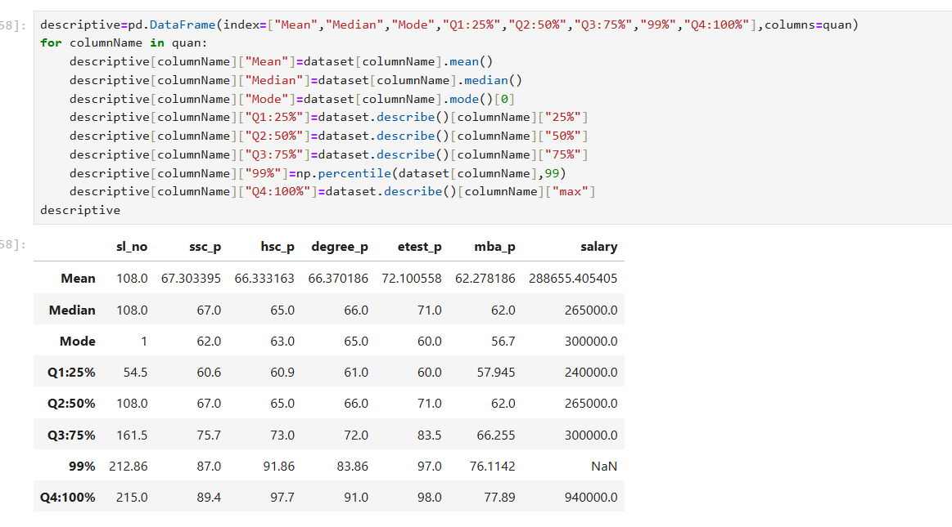

Hsc_p

Q1 to Q2 = 4.1 % difference and mark increased by 4 percentage from Q1
Q2 to Q3 = 8% difference and mark increased by 8 percentage from Q2
Q3 to 99% = 18.8% difference and mark increased by 18 percentage from Q3
99% to Q4 = 6% difference and mark increased by 6 percentage from 99%

Degree_p

Q1 to Q2 = 5% difference and mark increased by 5 percentage from Q1
Q2 to Q3 = 6% difference and mark increased by 6 percentage from Q2
Q3 to 99% = 11.8% difference and mark increased by 11 percentage from Q3
99% to Q4 = 7.14% difference and mark increased by 7 percentage from 99%

Etest_p

Q1 to Q2 = 11% difference and mark increased by 11 percentage from Q1
Q2 to Q3 = 12.5% difference and mark increased by 12 percentage from Q2
Q3 to 99% = 13.5% difference and mark increased by 13 percentage from Q3
99% to Q4 = 1% difference and mark increased by 1 percentage from 99%

MBA_p

Q1 to Q2 = 4% difference and mark increased by 4 percentage from Q1
Q2 to Q3 = 4% difference and mark increased by 4 percentage from Q2
Q3 to 99% = 10% difference and mark increased by 10 percentage from Q3
99% to Q4 = 1% difference and mark increased by 1 percentage from 99%

